

Ashcroft Surgery
Newlands Way
Eccleshill
Bradford
BD10 0RF
01274 637076

Repeat Prescribing Policy

Policy/ Protocol/ Management Plan Name: Repeat prescribing policy
Author: Dr P Bamber, Dr K Khan, Catherine Norris
Editor: P Bamber
Version: 1
Approved by: GP Partners
Date Approved: November 2010, latest review July 2015
Next Review Due: July 2018
Electronic Location: http://www.ashcroftsurgery.co.uk/repeat-prescribing-policy/

Contents

Section | Topic | Page
1.  2.  3.  4.  5.  6.  7.  8.  Appendix A  Appendix B  Appendix C  References | Aims of Policy  Introduction  Stage 1 - Authorisation  Stage 2 – Production of Prescription  Stage 3 – Review  Stage 4 – Systems for checking compliance  Stage 5 Signing Prescriptions  Miscellaneous  Medicines unsuitable for generic prescribing  Protocol for review of un-ordered repeat medicines  Repeat medication services | 2  2  3  4  7  9  9  10  13  14  17  20

Aims of Policy

- To standardise repeat prescribing processes and protocols within general practice
- To enable staff to understand their roles and responsibilities around repeat prescribing
- To provide guidance on good repeat prescribing process and procedures
- To ensure safeguards are in place to minimise error and reduce risk

Introduction

Definition of a Repeat Prescription

‘A prescription issued without consultation’, whether the consultation is face to face or on the telephone.¹
The production of repeat prescriptions is a team approach with input not only from the prescriber, but also from other members of the healthcare team to produce high standards of practice and care.^{2, 3}

There are five main stages in the repeat prescribing process:
Stage 1 Authorisation
Stage 2 Production of a prescription
Stage 3 Review
Stage 4 Compliance Check
Stage 5 Signing of prescriptions
Stage 1 Authorisation ^{3, 4}

Authorisation is the decision by a prescriber that a particular medication is suitable to be obtained on repeat prescription for a particular patient.

The prescriber should be satisfied that the patient is stable on the medication and that the medicine is well tolerated and still needed.^{5, 6}

Only prescriptions which have been authorised may be issued by non-clinical members of staff.^{6, 7} Authorised medication only includes medicines on “repeat templates” on SystmOne. It does not include medication that appears in for example the following sections of the patient medication record:
- Acute/ Current (‘medication’ on SystmOne)
- Past History

Prescribers should identify and create guidelines on which medicines they are happy to issue on a repeat basis.^{11, 23} Repeat prescribing is justifiable and allows prescriptions to be managed but should be limited to medicines which are prescribed for long term therapy to patients who are stable.^{11, 23, 24}

Medicines that are subject to monitoring and dose titration (e.g. some new medicines following discharge from hospital) should not be added to the repeat until they are deemed to be safe and effective for the patient and/or there is clear protocol for issuing repeats subject to the results of clinical investigation e.g. blood monitoring reports and their interpretations. Alternatively a short review date or quantity should be entered to ensure they are flagged up for review early.

Antibiotics, antifungals and antivirals should not be added to repeat, unless in exceptional circumstances e.g. cystic fibrosis patients.

Careful consideration should be taken on the following classes of medicines as to whether they should be put on repeat to ensure appropriate follow-up:
- Antidepressants
- Antipsychotics
- Anti-mania medication
- Hypnotics
- Benzodiazepines
- Anxiolytics
- Controlled drugs (Schedule 2 or 3)

System access rights (business functions) for non-clinical staff should only allow prescriptions to be generated for items appearing on the repeat list. They may, however, have ‘read-only’ access to the other sections. For SystmOne practices this is B0401. Only members of staff with relevant qualifications should be allowed to add medication to records (Business function - B0278).

Number of days supply
Each repeat item should be for 28 days (or 56 days if considered appropriate for that patient, in which case all repeats should be for 56 days). This ensures that the patient can request all their medication together minimising wastage due to mismatched schedules.^{1, 7, 14} (It may not be possible to prescribe certain items for a common number of days – e.g. special containers, ‘when required’ items, the contraceptive pill and HRT. Prescription quantities should be in multiples of 28 usually not exceeding 56 days in line with DH recommendations). If it is appropriate for the patient, it is preferable to issue whole pack sizes (sometimes 30) rather than 28 days as this avoids wastage and broken packs.

Generic prescribing
The practice has an agreed policy to prescribe generically unless agreed where brand prescribing is needed for safety or cost effectiveness, in which case it is in the SystmOne drug formulary as the agreed choice. Appendix B lists medicines unsuitable for generic prescribing.

Stage 2 Production of Prescription

2.1 Repeat requests

Repeat requests should ideally be received in writing on the repeat slip/ counterfoil or online, as they are more likely to be processed accurately.

Requests received on repeat slips:
  - minimise transcription errors
  - minimise confusion with brand and proprietary name pronunciation
  - avoid matching the request to the patient’s record^{7, 8, 9}
  - allows prescriptions to be processed with no interruption from further calls
  - can be deposited in a post box in the reception area to avoid disturbing staff unnecessarily

This practice accepts requests electronically via the website and we are in the process of phasing out email requests.. Staff check for repeat requests at regular intervals. The repeat prescribing request should not be processed without all the relevant information highlighted below.

This practice does not accept telephone prescription requests except in exceptional circumstances when administrative staff should ensure they ask sufficient questions to process the repeat request accurately.

The questions asked via the telephone should cover ALL the following information:

- Patient’s Full Name
- Date of Birth
- Address
- Telephone Number (on which to be contacted should the prescriber refuse to issue the request).
- Medication Requested:
  - Name
  - Strength
  - Form
  - Dosage Instructions

If the patient forgets/ loses the repeat slip then a repeat slip can be printed from the patient’s medication record or alternatively a request slip could be completed by the patient.

Early requests for items are permitted in certain circumstances ie if a patient is due to go on holiday; any query re legitimacy should be brought to the doctor’s attention verbally asap if urgent or via paper tag if for within 48hrs.

2.2 Repeat prescriptions should be prepared with accuracy by a receptionist who is trained in the role of repeat prescribing

All personnel involved in the repeat prescribing process need to be sufficiently trained and have read and understood the practice repeat prescribing policy.^{5, 6, 7, 10}

2.3 A computer system should be used to issue all prescriptions

All prescriptions should be generated by computer (see exception below)

Computers
- warn of possible interactions, contra-indications and side effects.
- are used as a source of data and audit to improve prescribing quality and maximise cost effectiveness.1, 10, 11, 12, 13, 14, 15, 16, 17
- provide the doctor with a profile of their prescribing habits.
- provide the patient with a copy of the items that have been authorised as a repeat prescription, which can be used to request a repeat.

Home visits
A blank prescription is generated from the patient record on SystmOne to be completed on home visits. This ensures the patient details are accurate and legible. Drug details are entered on return to the surgery.

Exception
If for any reason it is not possible to produce a computer-generated prescription, then the details must be added to the patient’s record as soon as possible, since this ensures an accurate record and allows for a double check on an contraindications or drug interactions.

Prescriptions that are issued by other prescribers eg hospitals need to be verified and then added to the patients repeat screen. This again allows for the flagging of important interactions especially with medicines such as warfarin, TB medicines and transplant medicines.

Medicines dispensed by the hospital need to be added to the patient’s record under the ‘other medication’ section (hospital). This will allow significant drug interactions to be avoided and will make it impossible for the items to be issued by the practice.

2.4 Time to generate repeat prescriptions should be less than 48 hours

Sufficient time should be allowed for accurate production, checking and signing before collection by the patient.⁷

The patient should be informed of the turnover time (no more than 48 hours) in order to leave adequate time to order a repeat prescription when their medication is running low. This information is included in the Windhill Green patient information booklet produced by the practice.

2.5 Appropriately qualified members of staff
Tasks must only be carried out by appropriately qualified members of staff. Where a clinical judgement needs to be made (e.g. queries, amendment of review date, re-authorisation, review of hospital discharge) these must be performed by a qualified prescriber who is acting within their area of competence. Alternatively, another appropriately qualified clinical member of staff, e.g. a practice pharmacist, may undertake this role. The role is agreed and determined by SystmOne access rights.
2.6 Processing a Request for a Repeat Prescription
On-line
Via SystmOne patient access

Patient communicates request to surgery

In Writing
Use either repeat slip or complete pro forma in full (patient may complete pro forma themselves if able)

Check the patient’s name, address and date of birth against the computer screen record

Via Telephone (exceptional)
Ensure all questions are asked
on telephone checklist

Check that the items requested are on the patients repeat list.
If the patient requests any items not on the repeat list, refer to the GP/ pharmacist

Place request in pile B: ‘requests with queries’ and leave for GP/ pharmacist to deal with

Write nature of problem on the pro forma

If there are discrepancies refer to GP/ pharmacist.
If dosage instructions are missing they must be inserted by the GP/ pharmacist
If the item appears on the repeat list, check that name, form, strength and dosage instructions are identical to the request

If past review date refer to GP/ pharmacist to re-authorise
Check medication review date has not been exceeded. NB S1 will allow 1 x issue past review date

Check compliance to ensure patient is not under/over-using medication. NB S1 will NOT always warn you
If patient is under/over-using medication refer to GP/ pharmacist

Issue item on request
The name, address and date of birth must be checked with the person collecting the repeat prescription to confirm the identity of the patient. It is good practice to check the number of items the patient is expecting to receive, so any discrepancies can be dealt with immediately.

Place prescription into pile A: ‘requests with no queries’ and leave for GP to sign
3.0

Stage 3 Review

3.1 Review Dates

- All medications on a repeat template should have a review date. It is preferable to have a review date rather than the maximum number of issues. However, certain medications e.g. clopidogrel may need a maximum number of issues limit to make sure it is not prescribed beyond the recommended period.

- The review date for stable medications will be 12 months. It should be same for all medications on the template. However, it may be different for certain medications e.g. antidepressants or DMARDs.

3.2 Informing the patient that they need to make a review appointment

When a patient requests a repeat prescription, the receptionist should check that the repeat item(s) is/are within the authorised period.
i.e. the review date has not been exceeded
OR the number of authorised prescriptions has not been exceeded

If the review date is approaching, the item(s) can be issued and the patient informed that a review appointment is due by either putting a note on the script and/or informing the chemist to let the patient know in case of delivered medications.

If the review date has been exceeded the prescription must NOT be issued by the receptionist; it should be brought to the doctor/pharmacist’s attention as an acute medication task.

For clinicians: When you receive the acute medication task
- Check if the patient has recently been seen e.g. by the nurse for a chronic disease review. If you feel that the review can be done without seeing the patient then use the medication review template and update the medications.
- If patient has not been seen recently or there are medications e.g. painkillers etc that have not been covered by chronic disease review, then send a task back to reception to arrange a medication review. At the review update the template and review dates.

From next year, once our medication review template and procedure is up and running the step of sending the acute task to clinician can be avoided by adopting the following procedures:
- When nursing team sees a patient for a review on chronic disease, they can send a task to doctor to update medications provided the patient is not on any other medications.
- When reception staff sees a medication review date approaching they should book the patient in with a doctor/pharmacist, as it will be assumed that their 12 month review is now due.

3.3 Length of review period

The default for review period is 12 months, but it can vary dependent on the disease state or medicine being reviewed. Review periods should be stated individually with none being left longer than a year.

3.4 At review

During a review patients should be considered individually, with respect to their illness and medication.

The medication review template should be used.

The person reviewing the patient must be satisfied that the patient still requires long term medication and will check:
- which medicines are being taken
- whether the medication is at a stable dose
(ii) whether the medication is achieving the desired effect
(iii) whether the patient is experiencing any intolerable side effects
(Side-effects/ ADRs/ allergies should be recorded in the patient’s notes.)
(iv) whether the medication is still appropriate and at an appropriate dose.
(v) whether the patient understands the purpose of the medication
(vi) that the patient is able to take the medication
(vii) that it is the most suitable medicine and there is no better alternative
(viii) any medicines which are not being ordered and duplicate medicines, ensuring they are deleted from the patients’ medication record.
(ix) that the patient is not abusing their medication
(x) that any necessary tests have been carried out at appropriate intervals e.g. TFTs, DMARDs monitoring
(xi) the dosage instructions are clearly written on the prescription. If the prescription states ‘when required’ then a maximum dose needs to be stated.
(xii) that all medication is prescribed in equivalent quantities. The quantities must be sufficient and not excessive.
(xiii) that prescribing is generic where appropriate
(xiv) all other medications prescribed (including those from other organisations) and over the counter medicines are identified
(xv) that the patient is informed of the next review date
(xvi) that patients recalls and QOF are up-to-date.

Stage 4 Systems for checking compliance

The computer system should provide a method of checking the patient’s compliance.^{1, 20} SystmOne show a red/amber/green flag for each medication which, if the quantity and duration of issue are correct, will give a compliance indication. Also and ‘empty tablet bottle’ icon is displayed when a repeat has not been issued – see below where he simvastatin has not been issued for 40 days even though it should have been every 7 days.

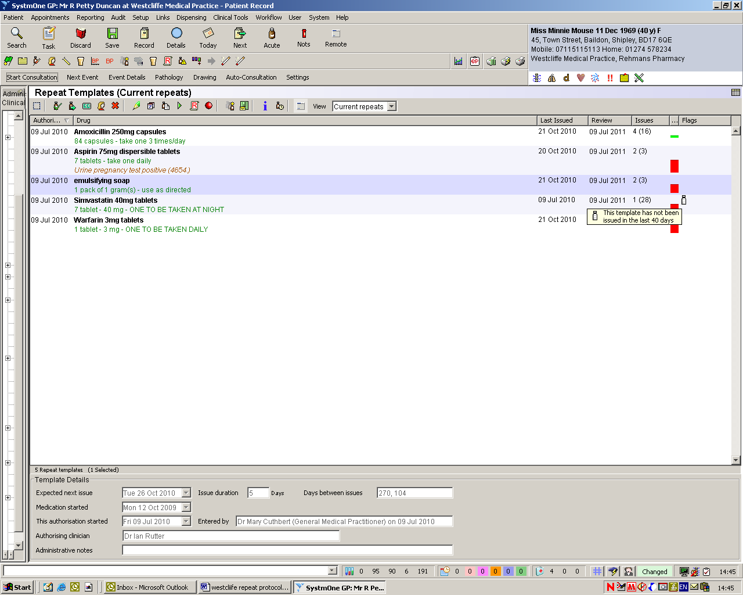

The importance of checking compliance should be emphasised to staff processing requests for repeat prescriptions, highlighting the importance of both under and over use.

The way in which the computer indicates compliance must be understood by all the receptionists processing repeat prescriptions.

When under/ over-use for a particular patient is shown as red on SystmOne for a medication then it should be referred to the prescriber.

Early requests for items should be permitted in certain circumstances ie if a patient is due to go on holiday, even though the computer will identify this as overuse. Please check with a doctor before issuing by sending a task.

Medicines which can be taken on a ‘when required’ basis may be flagged by the computer as being underused e.g. pain-relief, indigestion remedies etc. Staff who process repeat prescriptions should be aware that this is acceptable although should still be brought to the doctors attention.

Stage 5 Signing repeat prescriptions
Prescribers have an allocated and protected time set aside each day for signing/ reviewing repeat prescriptions. This need not necessarily be at the same time each day.

The prescriber must have access to the patients’ medical notes when signing/ reauthorising repeat prescriptions.

Miscellaneous

Hospital discharge and home visits
Hospital letters and discharge medication notes are scanned on the day of arrival and put into a GP document area on patient SystmOne record for review by an appropriate clinical member of staff for newly initiated medicines and alterations to previous therapy, and the repeat system updated.²⁰ Letters requiring same day action are placed onto the blue board for the oncall doctor.

Hospital formularies are often very different from a practice formulary and medicines may be temporarily substituted whilst in hospital and not changed back once the patient is discharged, or a medicine may be initiated in hospital that has cheaper alternatives in the community which are equally effective.

Evidence should be sought:
- whether the medicine is intended to be repeated
- that there is no unintentional duplication of existing medication
- that medication has not been stopped by the hospital in error
- what is the responsibility of the hospital and what of the practice in the prescribing and monitoring of a drug.

Shared care drugs
For medicines of a more specialist nature, shared care arrangements must be provided by the specialists before the GP can prescribe e.g. DMARDs, transplant drugs. The shared care protocol defines who takes responsibility for diagnosis, monitoring and prescribing and under what circumstances responsibility for prescribing should be handed back to the specialist. See separate policy for DMARDs.

So called ‘red drugs’, or ‘hospital only’, are drugs that should not be prescribed in primary care. These include items such as chemotherapy and drugs being used out of license e.g. sildenafil for Crest syndrome or primary pulmonary hypertension. By signing the prescription the prescriber assumes legal responsibility and therefore must be satisfied that he/she has the necessary clinical knowledge and skills before taking on the prescribing of any medicine.

Special products

“Specials” is a term applied to a group of medicines that do not have product licenses. They are usually very expensive and require the community pharmacist to order the product in specially. They are often listed on the practice computers but characteristically they have no price listed against them.
“Non Multilex drugs” are drugs not on the GP computer system’s pick list of medicines. Prescribers can create non-multilex additions to the prescribing system but this would be in exceptional circumstances. If it does not appear on the list there is probably a good reason. In this situation seek advice from clinical pharmacy support.

There are five main reasons why GPs should not prescribe a special without being fully aware and having considered alternatives.

- The product may not have a product license and therefore the prescriber is liable for the product quality.
- The medicine is often very expensive e.g. calcium carbonate liquid special 120mg/5ml can cost £1,236 per item.
- The supply is not guaranteed and the patient may have periods without treatment.
- It causes significant inconvenience for the community pharmacist to obtain the supply.
- Some specials are not listed on GP systems and have to be entered as non-multilex drugs. Consequently drug interactions/cautions etc are not highlighted e.g. methotrexate special and penicillin.

Before prescribing a special ask the following questions.
  - Is there a valid indication? There may have once been a valid indication but the patient may no longer be likely to be benefit
  - Is the medicine reasonable to be prescribed by a non-specialist? The medicine may be appropriate for the patient but of a specialist nature.
  - Can the patient really not swallow solid dosage forms?
  - Is there a licensed equivalent? Use the BNF or the Drug Tariff to identify if there is another product that you can use as an alternative.
  - Is there a less expensive special? If a liquid must be used and there is no licensed alterative then consider a special that is less expensive. Ask clinical pharmacy support for advice.

Safe and secure handling of prescriptions
The practice has a policy which covers the safe and secure storage and handling of prescriptions in line with the NHS BA policy.

Explaining the process to patients
When a patient is initiated on repeat medication the process for ordering should be explained to the patient and an information leaflet offered. This leaflet can be found on the practice website. There are also instructions on the repeat items print out.

Patient information leaflet http://www.ashcroftsurgery.co.uk/calling-us-about/prescriptions/

Nursing and residential homes and monitored-dosage system requests
There is an allocated GP for each care home to improve continuity of care. Repeat prescribing is monitored according to practice protocol.

Metered Dose System (e.g. Dosette) requests are processed by a dedicated member of staff at each site (see below for procedure for changes to medication).

Repeat Dispensing
Repeat Dispensing allows pharmacies to manage and dispense repeatable NHS prescriptions in instalments for medicines and appliances, in partnership with the patient and the prescriber. The pharmacist ascertains the patient's need for a repeat supply and communicates any clinically significant issues to the prescriber. The aim of the service is to increase patient choice and convenience, to minimise wastage, to reduce the workload of General Medical Practices and to enable pharmacies to manage their workload.
The patient is given a repeatable prescription plus a number of batch issues (up to 12) which are usually held in the pharmacy. (see NHS Bradford and Airedale Repeat Dispensing Manual for further details) Once the Electronic Prescription Service is established the batch issues will be stored electronically on the NHS spine and accessed up to 7 days before a repeat is required.
Dossett box and repeat dispensing.
For changes to repeat items for patient receiving a dossett
- It is the doctor’s responsibility to make the appropriate change on S1 repeat items.
- The doctor sends a task to the ‘dosset’ group clearly explaining the change ie dose change or if the item is new or being stopped. Specify when you want the change to start. Doctors should communicate directly with admin or the pharmacist if changes are required immediately.
- Administration members of the dossett team action the task and call the pharmacist to inform them of the changes. This is documented in the task before completion. Admin issue and print any repeat items to bring the changes in line with current repeats.

Repeat Medication Services

Policies regarding Repeat Medication Services by pharmacy contractors are included in appendix D, including nominating a Pharmacy for the Electronic Prescription Service (EPS):

Nomination is a new process that gives patients the option to choose or nominate a dispensing contractor to which their prescriptions can be sent automatically through the Electronic Prescription Service. There is specific legislation which governs nomination for EPS.

It states that GPs must not seek to persuade a patient to nominate a specific dispenser; and if asked by the patient to recommend a dispenser to nominate they must provide the patient with a list of all the dispensing contractors in the area who provide an EPS service. NHS choices (www.nhs.uk) can be used to provide details of which pharmacies are near to the patients home, surgery or place of work.

Appendix A Medicines Unsuitable for Generic Prescribing

There are some circumstances where generic prescribing may be unsuitable and branded prescribing preferred. These include situations where:
- There is a difference in bioavailability, especially where the medicine has a narrow therapeutic index.
- Modified release preparations are not interchangeable.
- There are important differences in formulation between brands of the same medicine.
- Products contain multiple ingredients and brand name prescribing aids identification.
- Administration devices (e.g. inhaler or self-injection) have different instructions for use and patient familiarity with the same product is important.
- Different preparations of the same medicine have different licensed indications.
- The product is a biological rather than chemical entity.

This list is not exhaustive and inclusion in this table does not imply endorsement of use.
Medicine Category | Generic  name / group | Comments
Drugs with a narrow therapeutic index. | Aminophylline | Difference in bio-availability may affect plasma concentrations.
Drugs with a narrow therapeutic index. | Ciclosporin
Drugs with a narrow therapeutic index. | Carbamazepine
Drugs with a narrow therapeutic index. | Lamotrigine
Drugs with a narrow therapeutic index. | Lithium
Drugs with a narrow therapeutic index. | Phenytoin
Drugs with a narrow therapeutic index. | Sodium valproate
Drugs with a narrow therapeutic index. | Tacrolimus
Drugs with a narrow therapeutic index. | Theophylline
Certain  modified-release preparations | Diltiazem | Different formulations of these modified-release (m/r) preparations may have different clinical effects.
Certain  modified-release preparations | Mesalazine
Certain  modified-release preparations | Nifedipine
Controlled Drugs including patches  (Schedule 2 and3) | Morphine | Caution - differing dosage regimes for SR and XL preparations.
Controlled Drugs including patches  (Schedule 2 and3) | Oxycodone
Controlled Drugs including patches  (Schedule 2 and3) | Fentanyl
Controlled Drugs including patches  (Schedule 2 and3) | Buprenorphine
Inhalers | CFC Free Beclometasone | Always state the type of device e.g. accuhaler, turbohaler.
Inhalers | Dry powder devices | Always state the type of device e.g. accuhaler, turbohaler.
Multi-ingredient products | HRT | Generic prescribing may not be practical or may cause confusion due to multiple ingredients.
Multi-ingredient products | Oral contraceptives
Multi-ingredient products | Antacid preparations
Multi-ingredient products | Multi-ingredient ENT preparations
Multi-ingredient products | Multi-ingredient laxatives
Multi-ingredient products | Bath oils, creams, liquids or gels
Multi-ingredient products | Antiseptics
Multi-ingredient products | Disinfectants
Miscellaneous | Antipsychotic depot injections | These should be prescribed using the brand name to avoid confusion. Generic prescribing for these drugs may affect clinical response or contribute to dispensing or administration incidents.
Miscellaneous | Stoma care products & appliances
Miscellaneous | Wound products
Miscellaneous | Insulin
Miscellaneous | Nutritional products
Miscellaneous | Vaccines
Miscellaneous | Nicotine Replacement Therapy
Appendix B

Protocol for review of un-ordered repeat medicines: 6 monthly audit

Background

Repeat medicines are a convenient way for patients to order long term medicines. However not all repeat medicines are ordered. Some are not ordered because they are no longer required whilst others are intended to be prescribed by the GP but for various reasons the patient has stopped taking them.

The objectives of this audit are;

- To identify all the patients who have not ordered a repeat medicine in a defined time period (normally > 1 year)
- To identify those patients that need flagging up for a review with the GP or practice nurse as they ought to be talking the medicine.
- To identify those repeats which can be removed from the system as no long required.

Procedure

In SystmOne go to “set up” and “bulk operations”. Choose “repeat template stopping “which looks like this:

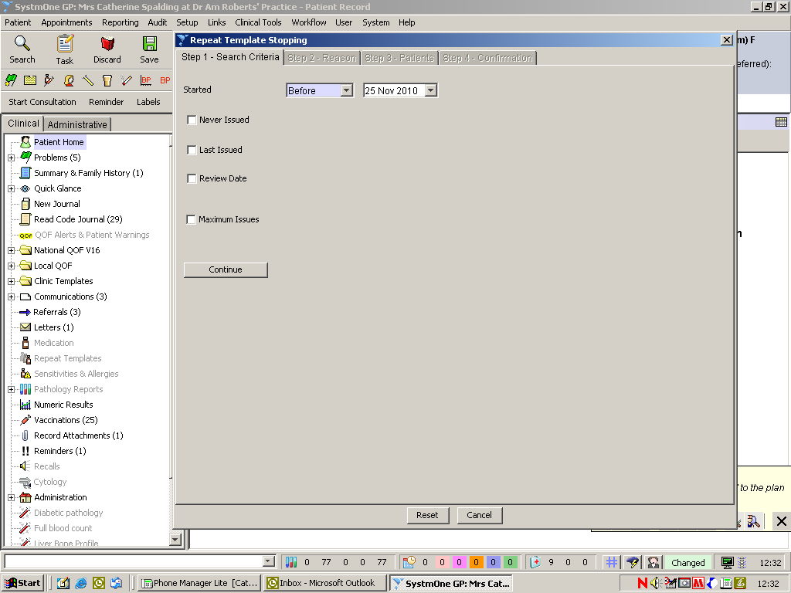

If you find that you don’t have user rights to do this either get them or find somebody who does.

Specify the time period that you are interested in which is normally any repeat templates not ordered in the last 12 months.

Run the search to produce a list showing patients name, the repeat medicine and the date last ordered.

You will need to use for professional discretion to determine which medicines should and should not be removed, and the time scale to look over. Agree these with the GP prescribing lead. Review this list for

- Medicines that the patient really ought to be taking e.g. angina drugs, glaucoma eye drops, inhaled corticosteroids for asthma. Highlight these to the appropriate health care professional so they can be invited for review- do not remove these medicines.

- “When required medicines” that the patient may order in the future e.g. GTN spray.- do not remove these.

- Medicine only used seasonally e.g. antihistamines for hay fever.- do not remove these.

All other medicines can be removed.

Appendix C Repeat Medication Services

Pharmacy contractors must ensure that Repeat Medication Services policies within the pharmacy are in line with professional standards and guidance. ²⁴ Specifically these should ensure that the pharmacy:
- Has the consent of the patient (or carer) before they request medication on their behalf.
- Confirms with the patient (or carer) which repeat items are required at the time of each repeat prescription request.
- Keeps an audit trail to identify the involvement of the patient/ carer in the request for repeat items.
- Ensures that unnecessary supplies are not made.
- Refers concordance or other problems encountered by the patient to the prescriber.
- Ensures that any message from the GP on the patients repeat medication slip (the right hand side of the FP10) is passed onto the patient.
- Records all interventions relating to the Repeat Medication Service which would include the referral of concordance issues and the conveying of any messages.

Specific guidance for Care Homes states that the routine ordering of the repeat prescriptions should be done by the care service and should never be delegated to pharmacy staff. Although it is not considered good practice the guidance makes a possible exception to this for patients who require MDS. For the practical reasons of assembly, the pharmacy may have to order the repeat prescriptions from the surgery on behalf of the patient. As this is not considered good practice it is advisable to record the reasons why the pharmacy is ordering medication on behalf of a patient in a care home.

1) Selecting a Pharmacy to collect prescriptions

The pharmacy must receive written consent from the patient to collect their prescription from the practice using a process which is auditable. This should where possible be from the patient themselves. In certain circumstances it is acceptable for a patient’s representative to provide consent. This may be
- On behalf of a child by their parent or guardian
- On behalf of an adult incapable of nominating a pharmacy by their relative or carer

NB a pharmacy contractor is unable to provide consent on behalf of a patient choosing their pharmacy.

The patient should receive both written and verbal information explaining the repeat-collection scheme. This should include a statement to ensure the patient understands that they can cancel the collection-delivery arrangements at any point if required.

Once the pharmacy has received consent from a patient, it should be clearly marked on the patient medication record within the pharmacy. Where appropriate the pharmacy will also send a copy of the consent to the practice.

The chosen pharmacy can be indicated on the patient’s record at the practice and printed on the top corner of the prescription so reception staff can easily identify where the prescription should be sent.

In cases where a pharmacy receives a prescription not intended for their pharmacy it MUST be returned to the practice.

If the pharmacy does not have written consent to pick up a patient’s prescription and are requested to do so by the patient they should obtain this as soon as possible eg if the patient needs a prescription in an emergency they may telephone the pharmacy to request delivery providing verbal consent which needs to be reinforced in writing.

2) Ordering Repeat Medication

Repeat Medication should be ordered in writing using the repeat slip.

Patients should be questioned carefully to ensure that
- their medication has not changed since their last repeat eg Have you visited the doctor since your last repeat prescription? Have you started any new medication/ changed any of your medication?
- only the medication required is ordered. The patient should be asked about each item individually rather than asking whether they would like all items on their repeat.

Where a pharmacy provides a managed repeat system for the patient where they automatically order on a set date the pharmacy must ensure that they determine from the patient which items they need. This must be done as near to the medication due date as possible to minimise wastages due to changes in treatment.

Patients should be informed when they will be able to collect their repeat medication or when it will be delivered. Patients should be educated to notify the pharmacy if they are accumulating medication.

3) Collection of Prescriptions from the surgery

Pharmacies will collect their repeat prescriptions at an allocated time arranged with the practice. Pharmacies should sign to say which prescriptions they have collected so that an audit trail is established.

4) Patient collection from the Pharmacy

The patient’s details should be confirmed to ensure the correct patient receives the medication.

If written consent has not previously been received the patient should be asked to complete a consent form.

5) Delivery of Prescriptions

It is good practice for pharmacies to have a SOP in place for the delivery of medication. It is important that each pharmacy has an audit trail in place so that deliveries can be traced. Records should include a date, time and signature on receipt from the patient.

The patient’s details should be confirmed on delivery to ensure the correct person receives the medication.

6) Nominating a Pharmacy for the Electronic Prescription Service (EPS)-Not currently available

Nomination is a new process that gives patients the option to choose or nominate a dispensing contractor to which their prescriptions can be sent automatically through the Electronic Prescription Service. There is specific legislation which governs nomination for EPS.

It states that GPs must not seek to persuade a patient to nominate a specific dispenser; and if asked by the patient to recommend a dispenser to nominate they must provide the patient with a list of all the dispensing contractors in the area who provide an EPS service. NHS choices (www.nhs.uk) can be used to provide details of which pharmacies are near to the patients home, surgery or place of work.
A community pharmacist or a member of the community pharmacy staff must not give, promise or offer to any person any gift or reward as an inducement to present an order for drugs or appliances on a non-electronic prescription form or non-electronic repeatable prescription or nominate the pharmacist as their dispensing contractor.
The PCT will work with key stakeholders such as the LPC and LMC to ensure compliance with legislation.
References

  - National Audit Office Controller and Auditor General. Repeat prescribing by general medical practitioners in England. No. 897 London: HMSO.1993.

  - Whittaker J. Improving control of the repeat prescribing system. Prescriber.1999; 10(22):37-53.

  - Wilson RG, Bojke C, O'Neill S, Winter MJ, Jones NK, Sugden RC, Purves IN, Kennedy JG. Designing, specifying and evaluating a new repeat prescribing process for UK general practice. Stud Health Technology Information 2000; 77: 219-223.

  - Cox S, Wilcox P, Young J. Improving the repeat prescribing process in a busy general practice. A study using continuous quality improvement methodology. Quality Health Care. 1999; 8:119–125.

  - Zermansky A. Who controls repeats? Br J Gen Pract.1996; 46:643-647.

  - Zermansky A. Errors in repeat prescribing systems. Pharmacy in Practice. 2002; 12(3): 96.

  - Speak G. Practice prescribing systems: an obstacle to progress? Primary Care Pharmacy. 2000; 1:52-54.

  - Drury VWM. Repeat Prescribing - a Review. J R Coll of Gen Pract. 1982; 32:42-45.

  - Department of Health. NHS Plan. London: HMSO. 2000.

  - National Prescribing Centre. GP Prescribing Support. NHS Executive: Crown Copyright. 1998.

  - Repeat Prescribing-is it necessary and can it be safe? Drug Ther Bull.1986; 24(14): 54-56.

  - Sykes D, Westwood P, Gilleghan J. Development of a review programme for repeat prescription medicines. Pharm J. 1996; 256:458-460.

  - Difford F. Computer controlled repeat prescribing used to analyse drug management. BMJ.1984; 289:593-595.

  - The Sowerby Unit for Primary Care Informatics. The quality of general practice repeat prescribing. Newcastle: University of Newcastle-upon-Tyne.

  - Halliday J, Rooney F, Henderson M, Kirby-Jones S, Scahill L. A framework for an ideal prescribing system. Pharm J. 2002; 268:842-843.

  - Roland MO, Zander LI, Evans M, Morris R, Savage RA. Evaluation of a computer assisted repeat prescribing programme in a general practice.BMJ.1985; 291:456-458.

  - Telling JP, Davies KR, Difford F, Fornear JE, Reading CA. Developing a practice formulary as a by product of computer controlled repeat prescribing. BMJ. 1984; 288:1730-1732.

  - Connolly JP, McGavock H. Repeat Prescriptions: Which Diagnoses, Which Drugs? Pharmacoepidemiology and Drug Safety.2000; 9:305-311.

  - British Guidelines on the Management of Asthma. Thorax. 2003; 58:Suppl 1.

  - Department of Health. National Service Framework for Older People. London: DOH. 2001.

  - British National Formulary. 44th edition. Pharmaceutical Press. London. 2002. p4.

  - Bennett JW, Glasziou PP. Computerised reminders and feedback in medication management: a systematic review of randomised controlled trials. MJA. 2003; 178(5):217-222.

  - Audit Commission. A Prescription for Improvement. Towards more rational prescribing in general practice. London. HMSO.1994.

  - McGavock H, Wilson-Davis K, Connolly JP. Repeat prescribing management - a cause for concern. Br J Gen Pract.1999; 49:343-347.

  - RPSGB. Professional Standards and Guidance for the Sale and Supply of Medicines. London 2007

